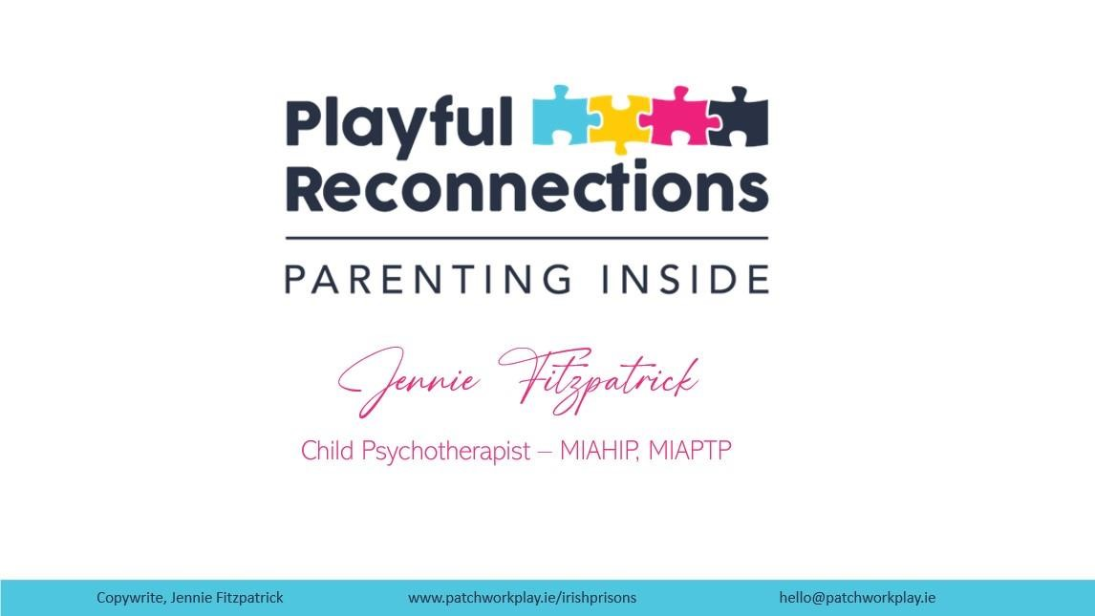

# References

Harris, Z. L., & Landreth, G. L. (1997). Filial therapy with incarcerated mothers: A five week model. *International Journal of Play Therapy, 6*(2), 53–73.

Landreth, G. L., & Lobaugh, A. F. (1998). *Filial Therapy With Incarcerated Fathers:*

*Effects on Parental Acceptance of Child, Parental Stress, and Child Adjustment. Journal of Counseling & Development, 76(2), 157–165.*

Gilmartin, D., & McElvaney, R. (2020). Filial therapy as a core intervention with children in foster care. *Child Abuse Review, 29*(2), 159– 166. [https://doi.org/10.1002/car.2602](https://psycnet.apa.org/doi/10.1002/car.2602)

Ford, Katharine, et al. "Understanding the prevalence of adverse childhood experiences (ACEs) in a male offender population in Wales: the prisoner ACE survey." (2019).

Merrick MT, Ford DC, Ports KA, et al. *Vital Signs:* Estimated Proportion of Adult Health Problems Attributable to Adverse Childhood Experiences and Implications for Prevention — 25 States, 2015–2017. MMWR Morb Mortal Wkly Rep 2019;68:999-1005.

Ford, K., Bellis, M.A., Hughes, K., Barton, E.R. and Newbury, A., 2020. Adverse childhood experiences: a retrospective study to understand their associations with lifetime mental health diagnosis, self-harm or suicide attempt, and current low mental wellbeing in a male Welsh prison population. *Health & justice*, *8*, pp.1-13.

Jones CM, Merrick MT, Houry DE. Identifying and Preventing Adverse Childhood Experiences: Implications for Clinical Practice. *JAMA.* 2020;323(1):25–26.

doi:10.1001/jama.2019.18499

Ford, K., Barton, E., Newbury, A., Hughes, K., Bezeczky, Z., Roderick, J. and Bellis, M., 2019. Understanding the prevalence of adverse childhood experiences (ACEs) in a male offender population in Wales: the prisoner ACE survey.

Irish Penal Reform Trust 2022, *Women in Detention*, Irish Penal Reform Trust,

viewed 29/04/2023 [<https://www.iprt.ie/women-](https://www.iprt.ie/women-offenders/#:~:text=In%202021%2C%20there%20were%20487,than%20for%20males%20since%202011)

[offenders/#:~:text=In%202021%2C%20there%20were%20487,than%20for%20ma les%20since%202011.](https://www.iprt.ie/women-offenders/#:~:text=In%202021%2C%20there%20were%20487,than%20for%20males%20since%202011)>

# Further Reading

Dr Perry, B & Winfrey, O (2021) *What happened to you. Conversations on Trauma, Resilience and Healing*. New York, Flatiron

Naish, S (2018) The A to Z of Therapeutic Parenting, strategies and Solutions.

London, by Jessica Kingsley Publishers

Archer, C & Gordon, C (2013) Reparenting the child who hurts: A guide to healing developmental trauma and attachments. London, Jessica Kingsley Publishers

Cohen, J. L, PH.D (2001) Playful Parenting. New York, Ballantine Books

Burke Harris N. *The Deepest Well : Healing the Long-Term Effects of Childhood Adversity*. Boston: Houghton Mifflin Harcourt; 2018.

Hoffman, K., Cooper, G., Powell, B., & Benton, C. M. (2017). *Raising a secure child*. Guilford Publications.

Levine. A, P Ph.D & Kline, M (2010) Trauma Through a Child's Eyes: Awakening the Ordinary Miracle of Healing. North Atlantic Books